**Amazing**

**People and**

**Places**

**of the Past**

**This packet belongs to_______________________________________________**

**Mummies**

Mummies are bodies of people who died a long time ago. They fascinate people because they tell us a lot about the past. We can learn about a people’s diet, health and community. Mummies were first found in 1798.

Throughout history dead bodies have been preserved in different ways. In Peru, a country in South America, bodies of the Inca people were found under the streets of a small town. They were wrapped in cotton bundles. The bundles could hold up to 7 bodies. They bodies were also wrapped with objects such as food, pottery, and clothing. The Inca preserved their loved ones by simply burying them in the earth. They lived high up in the mountains where decomposition occurs very slowly. The soil is filled with minerals that naturally preserve the body. The Inca also froze dead bodies in ice or simply placed them in a cave. The dry climate preserved them.

In Guanajuato, Mexico, between 1890 and 1950, people had to pay a tax to the cemetery to keep their loved ones buried. If a family was unable to continue paying the fee, the bodies were simply dug up. It was quickly discovered that the mineral-rich earth and dry climate would preserve anything that was buried in it. The bodies were grotesquely twisted and had disturbing looks of horror on their face. These strangely preserved bodies began attracting tourists. The cemeteries started charging people a viewing fee and a museum was eventually created. The museum is still there today.

Five thousand years ago in Egypt, bodies were also preserved by nature. Egyptians buried their loved ones in sand. This warm sand dried the bodies. However, Egyptians began to fear grave robbers so they buried their loved ones in closed tombs. Without the warm, dry sand, bodies began to decompose. The bodies had to be preserved before burial by workers called embalmers. It was a long process that took about 70 days.

First, embalmers removed the organs from inside the body. They took out the brain with a hook like tool through the nose! Next, they covered the body with salts and let it dry out for 40 days. Then, the body was rubbed with oils, wrapped in bandages and placed in a coffin. People wanted the dead to feel at home so they painted their tombs with happy scenes and put food, drink and other items that might be of use in the afterlife. Finally, the dead person’s family and friend’s had a great feast. They believed that after the feast the body would go on a long trip. They thought it would go through the underworld to the Judgment Hall. If the person led a good life, he would go to a heaven that looked much like Egypt.

**C:\Documents and Settings\Mary\Local Settings\Temporary Internet Files\Content.IE5\QGM5WBGE\MCj04420300000[1].wmfNonfiction Text Response Sheet C:\Documents and Settings\Mary\Local Settings\Temporary Internet Files\Content.IE5\KOLH3Q6G\MCj04404240000[1].wmf**

**Title**

|  |
| --- |
| **Main Idea** |
|  |

|  |  |
| --- | --- |
| **Author’s Point of View** | **Evidence** |
|  |  |

|  |  |
| --- | --- |
| **Text Structures** | **Evidence** |
|  |  |

|  |  |
| --- | --- |
| **Opinion** | **Fact** |
|  |  |

**Who Murdered King Tut?**

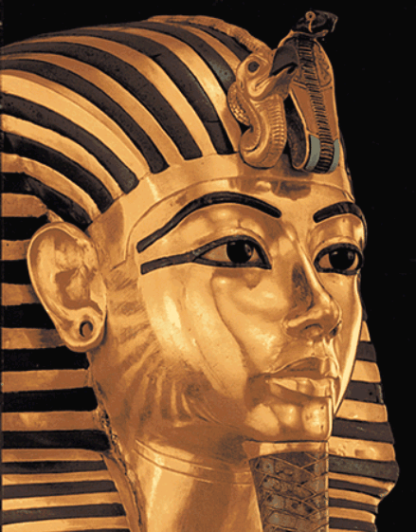

Ancient Egyptians buried King Tut in an area of hidden caves called the Valley of Kings. It is located near the Nile River. Tut’s mummy was discovered with an elaborate gold mask covering its head and shoulders. People in ancient Egypt wanted their loved ones to feel happy and at home in their afterlife so they put food, drink and other elaborate items in their tombs. King Tut’s tomb was discovered with treasures, including jewelry, statues, furniture, and even some of his toys.

The mystery of how King Tut died has interested people since Howard Carter, an archaeologist, found his tomb in 1922.

King Tut lived in Egypt more than 3,000 years ago. When he was 10 years old, his father died. Shortly after, Tut became pharaoh! A pharaoh is a king in ancient Egypt who was also believed to be a god. However, by the time King Tut was 18 years old, he was dead. Did someone murder him in order to become King?

Many experts believe he was not murdered. King Tut was a very sick boy. He suffered from a spine disease that made it difficult for him to turn his head. They say he most likely died from his illness.

However, because Tut was a pharaoh he was well taken care of. Although he suffered from his illness, he spent his childhood swimming in the Nile River and hunting ducks so despite what many experts believe, he could have led a long life. In addition, x-rays show a hole in King Tut’s skull indicating that he might have died from a head injury. Someone must have murdered him. It could have been either, his wife, his treasurer, his prime minister who was also his grandfather or his military chief. They all had motives to want him dead.

**His Wife (Ankhesenamen)**

Paintings in Tut’s tomb show a loving wife. However, she still could have had a reason to murder him. Not long after tut died, she wrote a letter to the leader of another nation. She asked for help in finding a new husband. In ancient Egypt, it was possible for women to become kings. Did she murder Tut to become king herself?

**The Prime Minister (Ay)**

Ay was Tut’s adviser and grandfather. After Tut died, Ay pressured Tut’s wife to marry him. Marrying her made him the king of Egypt. Shortly after their wedding, she mysteriously disappeared. Did he murder Tut to become king himself?

**The Treasurer (Maya)**

The treasurer managed King Tut’s money but there is evidence that they were also close friends. He rebuilt Tut’s tomb after it had been robbed. There is also a gift inside the tomb with Maya’s name on it. Were they really as good as friends as the evidence leads you to believe? Or were Maya’s actions just a decoy to cover up his true feelings? Maya could have been so jealous of the boy king that he murdered him.

**The Military Chief (Horemheb)**

Horemheb could have felt that he would have been a much better king. He might have thought King Tut was too young to protect Egypt from its enemies. After Tut’s grandfather died, Horemheb was crowned king. During that time, he tried to erase all the records of Tut’s life. During King Tut’s life, Heremheb drove his chariot. A chariot is a cart pulled by a horse. Horemheb could have pushed Tut off the chariot sending him to his death.

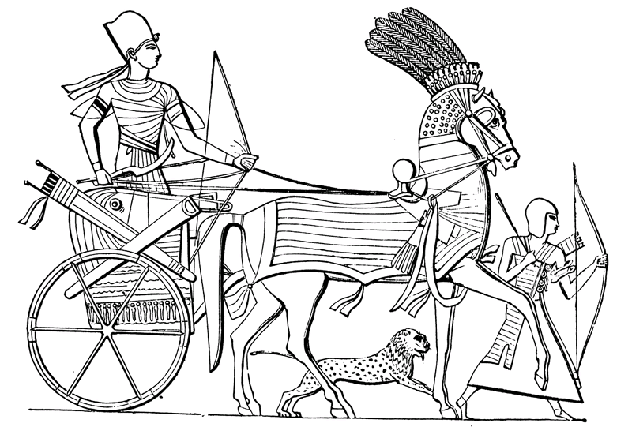

A chariot of ancient Egypt

A Chariot of ancient Egypt

Now that you have had a chance to compare the suspects and their motives, who do you think murdered King Tut?

**C:\Documents and Settings\Mary\Local Settings\Temporary Internet Files\Content.IE5\QGM5WBGE\MCj04420300000[1].wmfNonfiction Text Response Sheet C:\Documents and Settings\Mary\Local Settings\Temporary Internet Files\Content.IE5\KOLH3Q6G\MCj04404240000[1].wmf**

**Title**

|  |
| --- |
| **Main Idea** |
|  |

|  |  |
| --- | --- |
| **Author’s Point of View** | **Evidence** |
|  |  |

|  |  |
| --- | --- |
| **Text Structures** | **Evidence** |
|  |  |

|  |  |
| --- | --- |
| **Opinion** | **Fact** |
|  |  |

**From Pony Express to Computers**

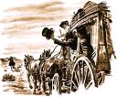

Mail delivery has changed overtime. In the past it was a long and difficult task. Now we are lucky. It just takes the click of a mouse.

In the 1800’s there were no trains to California. The telephone hadn’t been invented. For mail to go from the east coast to the west coast, it had to travel by wagon train across 2,000 miles. Or travel by boat down and up the coast of South America. Back then letters could take months to arrive on the west coast. News would be old by the time it reached its destination. Can you imagine not knowing about the assassination of President Lincoln until a month after it happened? Businesses ran at a slower pace, too. Storekeepers waited months for the goods they sold to arrive. And the companies they bought from waited as long to get paid.

In 1860, a private company came up with an idea to make mail delivery faster. They called it the Pony Express. The Pony Express used horseback riders to carry mail. At the time the Pony Express seemed like a great idea. It did speed up mail delivery. However, it went from taking months to deliver mail to weeks! Although people were excited about the Pony Express, two weeks is still a long amount of time. Can you imagine waiting two weeks to find out what your friend’s have been up to. Today, thanks to social networking sites like Facebook and Twitter, we practically know every move our friend’s make.

First, the letter went to Saint Joseph, Missouri. Then, Pony Express riders carried it west in relays, each rider taking the mail for a part of the journey. At designated points, new riders would take over. Finally, after about two weeks the letter would arrive at its destination.

It was extremely hard work for the riders. Flooded rivers, blizzards and desert heat made the trip risky, as well as occasional attacks by Indians. Riders also worried about wolves, mountain lions, bandits and horse thieves. Today, you can send a message to family members safely. You are not putting anyone in harms way.

Sending a letter through the Pony Express was also very expensive. It cost between one and five dollars for every half ounce. Now we can have an e-mail account for free. Even stamps just cost a few cents.

The Pony Express did not last long. It went bust in 1861. The telegraph had spread to many more places than before. When telegraph lines reached San Francisco, people could send messages and news to California in just minutes. Now wonder it went bust so quickly, despite its initial success, it really was an inefficient way to communicate. The telegraph was a much better way of communicating long distance.

However, today we still have it a lot better. Satellite TV carries news and information around the world instantly. We contact friends and family by social networking websites and e-mail. Thanks to airplanes and computers, businesses can receive goods the next day. Payment can also be immediate because banks can send money around the world electronically.

Now that we are use to speed, we want it all the time! That’s why we call letters sent through the mail “snail mail.”

**C:\Documents and Settings\Mary\Local Settings\Temporary Internet Files\Content.IE5\QGM5WBGE\MCj04420300000[1].wmfNonfiction Text Response Sheet C:\Documents and Settings\Mary\Local Settings\Temporary Internet Files\Content.IE5\KOLH3Q6G\MCj04404240000[1].wmf**

**Title**

|  |
| --- |
| **Main Idea** |
|  |

|  |  |
| --- | --- |
| **Author’s Point of View** | **Evidence** |
|  |  |

|  |  |
| --- | --- |
| **Text Structures** | **Evidence** |
|  |  |

|  |  |
| --- | --- |
| **Opinion** | **Fact** |
|  |  |

**Vesuvius Erupts!**

It was a scorching-hot morning on August, 24 in the year 79 AD. The town of Pompeii baked in the sunshine. Pompeii was a city in Italy that sat at the foot of an active volcano named Mount Vesuvius.

Although it was very hot, the townspeople went about their daily chores. Some were at the public fountain collecting water for the day. Others went to the marketplace to buy bread and cheese for breakfast or olives and eggs for dinner. Farmers were out in their fields.

In the packed taverns, people spoke excitedly about the afternoon’s games in the amphitheater. This was a stadium where huge crowds gathered to watch trained warriors called gladiators fight each other. These were very violent and cruel fights.

Just then, the ground shook. The shoppers in the market place shrugged it off as just another earthquake. Earthquakes were common in this area and seen as just a fact of life. They seldom did much damage.

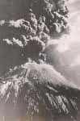

Suddenly there was a deafening boom – and the top of Mount Vesuvius, blew right off. A fountain of fire shot upward and huge black clouds rose into the sky. The ground shook with the force of the explosion.

Crowds ran screaming though the gloomy streets, upsetting market stalls and trampling fruit and vegetables underfoot. Even gladiators training in the amphitheater dropped their weapons and ran.

Some people rushed to save precious objects. Others tied cushions or towels to their heads for protection as they fled the streets of Pompeii. Men in charge of the areas warships turned their boats towards shore to help rescue the residents of Pompeii.

Ash spread by the winds rained down on the town for about 18 hours. Buildings started to collapse. Then high temperatures came, and gases, dust, and more earthquakes.

The Volcano’s eruption blanketed the town of Pompeii and the neighboring city of Herculaneum. Thousands of people died that day. Pompeii was buried under ten feet of ash while the town of Herculaneum was buried under 75 feet of ash.

Pompeii and Herculaneum were never rebuilt. The towns' locations were accidentally rediscovered in the 18th century. The ash preserved and protected a vibrant city against the elements until archaeologists unearthed this snapshot in time.

The area around Vesuvius is now open to visitors as a national park.

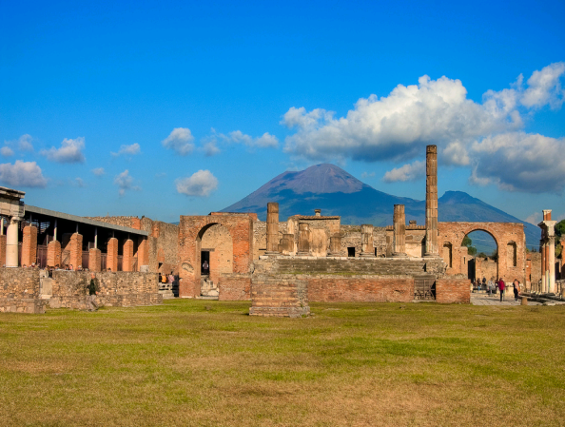

Mt. Vesuvius National Park

|  |
| --- |
|  |

**C:\Documents and Settings\Mary\Local Settings\Temporary Internet Files\Content.IE5\QGM5WBGE\MCj04420300000[1].wmfNonfiction Text Response Sheet C:\Documents and Settings\Mary\Local Settings\Temporary Internet Files\Content.IE5\KOLH3Q6G\MCj04404240000[1].wmf**

**Title**

|  |
| --- |
| **Main Idea** |
|  |

|  |  |
| --- | --- |
| **Author’s Point of View** | **Evidence** |
|  |  |

|  |  |
| --- | --- |
| **Text Structures** | **Evidence** |
|  |  |

|  |  |
| --- | --- |
| **Opinion** | **Fact** |
|  |  |

**Education Through the Ages**

Today, all fifty states in America have many laws about education. One of these laws says all children must go to school. Each state collects tax money from people who own houses and other types of property. Taxes are used to build schools, buy books, and pay teachers. In that way, everyone can go to school.

However, that was not always the case. For example, in ancient Greece, only boys were allowed to go to school. And their school was very different to the one that children of today attend. It was outside and the boys sat on dirt floors! They listened to their teacher whom they called wisdom seller. Also, it cost money so only boys from wealthy families were able to attend. If you were not able to go to school, you stayed home with your father and learned his trade (job). Girls stayed home with their mothers and learned how to cook and clean. Girls from rich families had private tutors come to their home and teach them other skills.

In America, during the Colonial days, education was also very different then it is today. Usually, people had to pay to send children to school as well. Not everyone could afford to send their children, and many young people, especially girls, never went to school. In school, most children were taught only to read and write. Children from rich families had a better education.

During the early 1800’s, people began to think it was important for all children to have an education. In 1852, Massachusetts passed a law which said that all children must go to school. Then other states passed education laws. At first, children only had to go to school four or five years. There were no high schools.

Now children must remain in school until they are sixteen. In some states, they must stay in school until they are eighteen. So in America, all children have a chance to learn.

**C:\Documents and Settings\Mary\Local Settings\Temporary Internet Files\Content.IE5\QGM5WBGE\MCj04420300000[1].wmfNonfiction Text Response Sheet C:\Documents and Settings\Mary\Local Settings\Temporary Internet Files\Content.IE5\KOLH3Q6G\MCj04404240000[1].wmf**

**Title**

|  |
| --- |
| **Main Idea** |
|  |

|  |  |
| --- | --- |
| **Author’s Point of View** | **Evidence** |
|  |  |

|  |  |
| --- | --- |
| **Text Structures** | **Evidence** |
|  |  |

|  |  |
| --- | --- |
| **Opinion** | **Fact** |
|  |  |