C:\Documents and Settings\Mary\Local Settings\Temporary Internet Files\Content.IE5\A09WZY9D\MC900027305[1].wmf **C:\Documents and Settings\Mary\Local Settings\Temporary Internet Files\Content.IE5\3KV1891C\MC900436682[1].wmf**

**ANIMALS**

**C:\Documents and Settings\Mary\Local Settings\Temporary Internet Files\Content.IE5\3KV1891C\MC900187477[1].wmf** C:\Documents and Settings\Mary\Local Settings\Temporary Internet Files\Content.IE5\45W752N7\MC900356133[1].wmf

**This packet belongs to _____________________________________________**

**The Trap-Door Spider**

Most spiders build webs to trap their prey. However, the trap-door spider does not need a web. Instead, it constructs burrows with a cork-like trapdoor. When the trap-door spider is hungry, she digs a hole about ten inches deep and an inch and a half wide. She makes a lid of soil and plants. She hinges the trap door to one side of the hole with webbing. It is difficult to see when it is closed because the plant and soil camouflage it. Now she is ready to hunt.

The trap-door spider waits until night. For hours, she stays hidden right below her door. She holds it open just a crack as she waits for an unsuspecting insect. The spider detects an insect is near the door by vibrations and, when it comes close enough, she pushes the lid open quickly. But the trap door is so strong that she could be locked out. So she leaves her hind legs and a part of her body under the open lid. Then the spider grabs the surprised insect in her jaws. Down they go into her nest! After all that hard work, the trap-door spider finally has a meal.

**C:\Documents and Settings\Mary\Local Settings\Temporary Internet Files\Content.IE5\QGM5WBGE\MCj04420300000[1].wmfNonfiction Text Response Sheet C:\Documents and Settings\Mary\Local Settings\Temporary Internet Files\Content.IE5\KOLH3Q6G\MCj04404240000[1].wmf**

**Title**

|  |
| --- |
| **Main Idea** |
|  |

|  |  |
| --- | --- |
| **Author’s Point of View** | **Evidence** |
|  |  |

|  |  |
| --- | --- |
| **Text Structures** | **Evidence** |
|  |  |

|  |  |
| --- | --- |
| **Opinion** | **Fact** |
|  |  |

**Can Animals Help us Detect Natural Disasters?**

**Wildlife Officials are Amazed that Few Animals Died in the Tsunami**

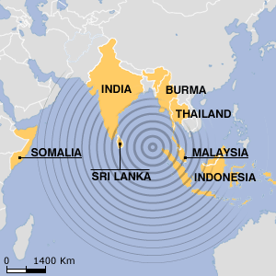

Map of area affected by the tsunami.

Hours before giant waves pounded coastlines in South Asia, many animals started behaving strangely. In Sri Lanka, elephants trumpeted frantically and fled to higher ground. Bats and flamingos deserted low-lying areas. Many other animals escaped unharmed.

Wildlife experts are amazed that many animals survived the tsunami. Experts say animals might have sensed the approaching waves and moved to higher ground.

The massive [tsunami](http://news.nationalgeographic.com/news/2004/12/1227_041226_tsunami.html) was triggered by a magnitude 9 earthquake off the coast of northern Sumatra island on December 26, 2004. The giant waves rolled through the Indian Ocean, killing more than 150,000 people in a dozen countries. However, relatively few animals have been reported dead. Along India's coast, where thousands of people died, the Indo-Asian News service reported that buffaloes, goats, and dogs were found unharmed.

Giant waves flooded low-lying parts of Yala National Park in Sri Lanka, home to a variety of animals, including elephants, leopards, monkeys, tigers, deer and 130 species of birds. The park employees reported only two water buffalos dead.

In Thailand, elephants carrying tourists bolted for the hills, and other elephants broke free of their chains. In one fishing village, nearly 1,000 locals escaped safely after birds squawked madly.

**More Wild Stories**

There have been many accounts of animals behaving strangely in other natural disasters as well. On February 28, 2001, a 6.8-magnitude quake struck the city of Seattle in the state of Washington. Animals behaved unusually beforehand. Some cats were said to be hiding for no apparent reason up to 12 hours before the earthquake; some dogs were barking frantically before the earthquake struck; and goats and other animals were showing obvious signs of fear.

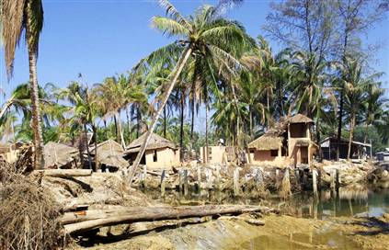

Resort in Thailand damaged by the tsunami.

Unusual animal behavior has also occured before avalanches. On February 23, 1999, an avalanche devastated a village in Austris killing dozens of people. The previous day, the chamois (small goat-like antelopes) came down from the mountains into the valleys, something they never usually do.

**Making Sense of It**

Why might animals have known trouble was on the way? Experts say that animals have better senses of hearing, smell, and sight than humans do. Those sharp senses help warn animals when natural disasters, such as volcano eruptions or earthquakes, are about to happen. At one time humans also had sharper senses, but lost the ability when it was no longer needed or used.

The senses of certain species are far stronger than what any human has. Dogs, for example, have a stronger sense of smell than humans and cats can see better in the dark than people.

Scientists say that animals might have felt the vibrations from the earthquake that set off the tsunami. In addition, many animals, including elephants, pigeons, and dogs, can also pick up infrasound. That is a sound that has too low of a pitch for humans to hear.

Elephants can hear or feel other elephants grumble up to 2 miles away, so they probably felt the earthquake. Their first instinct would be to move away from the direction of the sound.

Before the tsunami struck, animals may have started to flee because they saw other creatures running. Animals take their cues from other animals.

[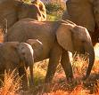](http://admin.satyacenter.com/item_files/article_347_0.jpg)

Elephants in Sri Lanka

**Hearing with Their Feet**

Scientists say that elephants can pick up vibration from earthquakes through their broad feet.

Elephants’ toenails are in their skin and not attached to the toes.

Elephants’ soles have sensitive foot pads that detect vibrations, such as those from an earthquake. This signals elephants to move to more stable ground.

**The Mystery Continues**

How animals sense danger has fascinated people for centuries. Most scientists, on the other hand, are skeptical.

"What we're faced with is a lot of anecdotes," said Andy Michael, a geophysicist. "Animals react to so many things—being hungry, defending their territories, mating, predators—so it's hard to have a controlled study to get that advanced warning signal."

In the 1970s a few studies on animal prediction were done, "but nothing concrete came out of it," Michael said. Since that time, there has been no further investigations into the theory of using animals to help us detect natural disasters.

#### However, in earthquake-prone areas of China, authorities have encouraged people to report unusual animal behavior, and Chinese scientists have an impressive track record in predicting earthquakes. In several cases they issued warnings that enabled cities to be evacuated hours before devastating earthquakes struck, saving tens of thousands of lives.

#### Animals are amazing predictors of natural disasters. By paying attention to unusual animal behavior, as the Chinese do, earthquake warning systems might be possible in California, Greece, Turkey, Japan and elsewhere. Millions of pet owners and farmers in earthquake-prone areas could be asked to take part in this project through the media. They could be told what kinds of behavior their pets and other animals might show if an earthquake were about to happen. If people noticed these signs or any other unusual behavior, they could immediately call a telephone hotline with a memorable number - in California, say, 1-800-PET QUAKE. Or they could send a message on the Internet.

At present, many millions of dollars are being spent for setting up early warning systems to detect natural disasters. Using animals to help us detect natural disasters would only cost a fraction of what it costs to come up with high-tech machinery. I hope that those responsible for spending this money will stop ignoring what animals can tell us.

**C:\Documents and Settings\Mary\Local Settings\Temporary Internet Files\Content.IE5\QGM5WBGE\MCj04420300000[1].wmfNonfiction Text Response Sheet C:\Documents and Settings\Mary\Local Settings\Temporary Internet Files\Content.IE5\KOLH3Q6G\MCj04404240000[1].wmf**

**Title**

|  |
| --- |
| **Main Idea** |
|  |

|  |  |
| --- | --- |
| **Author’s Point of View** | **Evidence** |
|  |  |

|  |  |
| --- | --- |
| **Text Structures** | **Evidence** |
|  |  |

|  |  |
| --- | --- |
| **Opinion** | **Fact** |
|  |  |

**Animals in Danger**

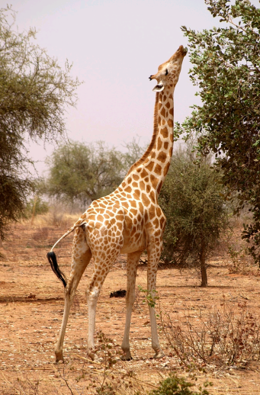The world is filled with many interesting and beautiful creatures however many are in danger of becoming extinct. Humans destroy their habitats to build farms, roads, shopping malls and to dig for minerals and other resources. An important mineral that is used in cell phones comes from the gorilla’s habitat. We also pollute their homes, cut down their trees and hunt them for food, medicine and just for fun. Animals will continue to become extinct if humans do not keep them out of danger.

There are a number of threats to giraffes in West Africa. The human population is growing in central Africa, where most giraffes live. Giraffes need the leaves of the acacia tree. The leaves of this tree provide the giraffe with not only nutrients but water as well. This is important in a land where there are not many lakes or water holes. However, humans need the land as well. As the human population grows trees are cut down for firewood and to make way for livestock, there is less and less land left for the giraffes and less acacia trees for them to feed upon. The people of Africa also need food. Giraffes can provide large quantities of meat. They are very tall. The average giraffe is from 14 – 18 feet tall and can weigh up to 3,000 pounds. Too many giraffes are being killed for their meat, hide and tail hair. As a result, the giraffe population is shrinking in West Africa.

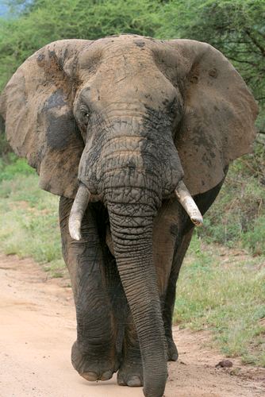 The mountain gorilla is another animal that is endanger. These animals live high up in the mountains of central Africa. The forests where Mountain Gorillas live are surrounded by rapidly increasing human settlement. The humans' need for land, food, and timber encroaches on the gorillas' habitat. Humans build roads, farms, and cut down trees. There is not much land and food left for the gorilla. As a result, gorillas raid human’s crops for food. Many African farmers kill the gorillas to keep them off their farms.

African elephants used to be hunted for their ivory tusks. People would pay a lot of money for the tusks, so hunters killed a lot of elephants. They made jewelry, statues, and piano keys out of the ivory. Today people are building farms and homes on elephants’ habitats. As a result, elephants are beingprevented from migrating between feeding and water sites.

Humans are realizing that giraffes, gorillas and elephants’ lives have value too. These animals attract tourists from all over the world. The tourists spend money. They need food and places to stay when they come to see the giraffes. This means more jobs for Africans. Law are being made to try to stop hunters from killing them. Land is being set aside to protect these gentle giants. If they are to survive outside of zoos, people must continue to preserve their habitats and find ways to protect these peaceful creatures.

**C:\Documents and Settings\Mary\Local Settings\Temporary Internet Files\Content.IE5\QGM5WBGE\MCj04420300000[1].wmfNonfiction Text Response Sheet C:\Documents and Settings\Mary\Local Settings\Temporary Internet Files\Content.IE5\KOLH3Q6G\MCj04404240000[1].wmf**

**Title**

|  |
| --- |
| **Main Idea** |
|  |

|  |  |
| --- | --- |
| **Author’s Point of View** | **Evidence** |
|  |  |

|  |  |
| --- | --- |
| **Text Structures** | **Evidence** |
|  |  |

|  |  |
| --- | --- |
| **Opinion** | **Fact** |
|  |  |

**A Polar Bear Problem**

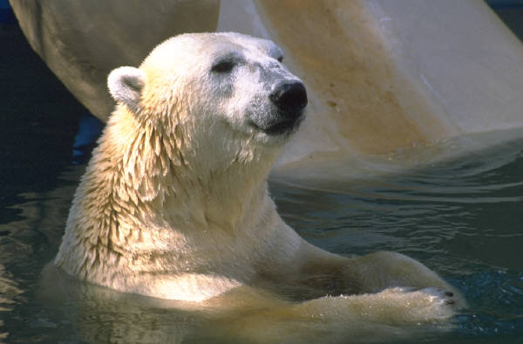

**The ice is melting early in Canada’s Hudson Bay area. That’s a problem for the area’s 1,200 polar bears. They need plenty of ice to travel over as they hunt for food.**

**Seal Meal**

**Polar bears mostly eat ringed seals. The seals are found in very cold seas. The bears stand on pieces of ice to be near the seals. When the seals pop up, the bears catch them.**

**With the ice melting earlier than it use to, the polar bears are having trouble getting to the seals. They are not eating, enough. They are becoming thinner and weaker.**

**Major Meltdown**

**In the Hudson Bay area, the ice melts three weeks earlier than it did 25 years ago.**

**“For every week a bear does not hunt on the ice, it becomes 22 pounds lighter. That’s dangerous,” said polar-bear expert Michael Goodyear.**

**What’s causing the ice to melt earlier? It is called global warming. This is a world wide rise in temperature. Experts believe it is caused when people pollute the air by burning fuel.**

**People burn fuel every time they drive cars or use electricity. So always remember to turn off the lights because you just might help save a polar bear.**

**C:\Documents and Settings\Mary\Local Settings\Temporary Internet Files\Content.IE5\QGM5WBGE\MCj04420300000[1].wmfNonfiction Text Response Sheet C:\Documents and Settings\Mary\Local Settings\Temporary Internet Files\Content.IE5\KOLH3Q6G\MCj04404240000[1].wmf**

**Title**

|  |
| --- |
| **Main Idea** |
|  |

|  |  |
| --- | --- |
| **Author’s Point of View** | **Evidence** |
|  |  |

|  |  |
| --- | --- |
| **Text Structures** | **Evidence** |
|  |  |

|  |  |
| --- | --- |
| **Opinion** | **Fact** |
|  |  |

**Twins at the Zoo**

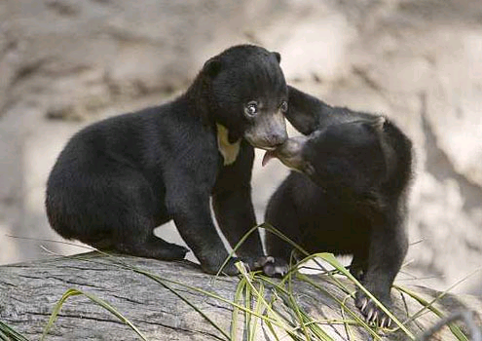

Pagi and Palu are twin Bornean sun bears who were born at the San Diego Zoo in 2008. Since sun bears are hard to find in the wild, the birth of these babies gave zoo keepers the rare chance to study the cubs up close.

**Meet Pagi and Palu**

Pagi and Palu had very different personalities while growing up. Palu was a huge momma’s boy always wanting to know where his mother was at all times while Pagi was a very independent explorer. Palu was also just plain huge. At 20 months, he weighed 95 pounds. His mother on the other hand only weighed 85 pounds at age 16! His sister Pagi is the small one. She weighed 72 pounds at 20 months. Besides being the bigger one of the twins, Palu was also very motivated by food while Pagi was more motivated by interaction. However, they both loved to fish and got very excited when zoo keepers put live fish in their pool.

**Champion Nappers**

While growing up, Pagi and Palu enjoyed many different hobbies however napping was one of their favorites. They both loved sleeping on the climbing structure. The zoo keepers noticed that Pagi would race through her breakfast in order to beat her brother to their favorite spot on top of the structure. Sometimes, if he was feeling brave, Palu would try to push Pagi out of the spot. Otherwise, he would just find another cozy place.

**Sun Bear Basics**

The Bornean sun bear live in tropical forest habitats on the island of Borneo in Indonesia, a country in Asia. Its name comes from the white or yellowish marking on the bear’s chest, which many people think looks like the rising or setting sun.

The sun bear’s long claws are perfect for ripping open trees as the bear looks for sap or insects. The sun bear’s long tongue makes reaching honey and insects inside trees and other tight places easy. They also eat small birds, fruit, lizards, and rodents.

The also have a fondness for coconuts and palm oil fruit. These are crops that are grown on large farms to bring to market. Therefore eating these foods has gotten the sun bears into a lot of trouble with humans. Humans often kill them because they see them as pests for tearing up trees on their plantations.

Sun bears have many other threats as well. They are hunted for their body parts which are used in traditional medicines. These are cute bears. Anther name for them is “dog bear.” They are often taken from the wild for the pet trade. In addition to all this, the trees in their habitat are being cut down.

According to International Union for Conservation of Nature, the population of the sun bear is thought to have declined more than 30 percent in the last 30 years. In order to help conserve them, the San Diego Zoo is trying to learn as much as possible about these small and fun-loving bears. They are also trying to educate people about these bears and the threats they face. They want to encourage people to save the bears so these cute creatures will be around for future generations.

**C:\Documents and Settings\Mary\Local Settings\Temporary Internet Files\Content.IE5\QGM5WBGE\MCj04420300000[1].wmfNonfiction Text Response Sheet C:\Documents and Settings\Mary\Local Settings\Temporary Internet Files\Content.IE5\KOLH3Q6G\MCj04404240000[1].wmf**

**Title**

|  |
| --- |
| **Main Idea** |
|  |

|  |  |
| --- | --- |
| **Author’s Point of View** | **Evidence** |
|  |  |

|  |  |
| --- | --- |
| **Text Structures** | **Evidence** |
|  |  |

|  |  |
| --- | --- |
| **Opinion** | **Fact** |
|  |  |

**Clever Creatures**

For many years, no one thought animals could use tools. Then in 1960, Jane Goodall, a scientist who studies primates, observed chimpanzees using sticks to collect termites out of a termite nest for dinner. It was the first time anyone had seen animals in the wild using tools. Now we know that all kinds of animals use tools.

Humans have created all kinds of tools from hammers and spoons to computers. However, animals usually use tools found in their habitats. Animals have created amazing ways to use the most ordinary objects. Scientists have observed smart animals using anything from rocks, leaves and sticks to even cars as tools.

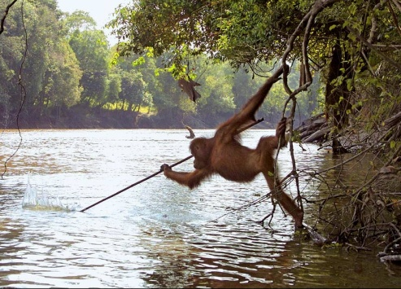In West Africa, chimpanzees have been observed banging nuts with a stone in order to crack them. Sea otters also use stones to hammer abalone shells off the rocks. These unbelievable animals hammer at a rate of 45 hits in 15 seconds. Clever crows in urban Japan have created a way to crack hard-shelled nuts. They drop the nuts onto cross walks and wait for them to be run over and cracked by cars. They then retrieve the cracked nuts when the cars are stopped at a red light.

Animals have also created clever ways to use sticks. Chimpanzees sharpen sticks and use them for hunting spears. They also use sticks to break open bee hives to get out the honey. Crows have been observed in the wild holding sticks with their beaks to extract insects from logs. A male Orangutan was seen using a pole to get fish after observing local humans spear fishing. Orangutans have also been observed using sticks to measure the depth of water and as walking sticks to support themselves when crossing deep rivers. Elephants often use sticks to swat flies or scratch themselves.

Orangutans have not only developed some amazing uses for sticks but for leaves as well. They make rain hats, sandals and even napkins. Chimpanzees have also been observed using leaves in some surprising ways. They make sponges out of leaves and moss. They then use them to clean themselves.

Now look around your environment. What can you find to use as a tool. Are you as creative as these clever creatures?

**C:\Documents and Settings\Mary\Local Settings\Temporary Internet Files\Content.IE5\QGM5WBGE\MCj04420300000[1].wmfNonfiction Text Response Sheet C:\Documents and Settings\Mary\Local Settings\Temporary Internet Files\Content.IE5\KOLH3Q6G\MCj04404240000[1].wmf**

**Title**

|  |
| --- |
| **Main Idea** |
|  |

|  |  |
| --- | --- |
| **Author’s Point of View** | **Evidence** |
|  |  |

|  |  |
| --- | --- |
| **Text Structures** | **Evidence** |
|  |  |

|  |  |
| --- | --- |
| **Opinion** | **Fact** |
|  |  |