**CHILDREN’S**

**TOPICS**

**C:\Documents and Settings\Mary\Local Settings\Temporary Internet Files\Content.IE5\6SA2D4CJ\MC900040341[1].wmf**

THIS PACKET BELONGS TO ____________________________________

**Struggles with Bullies**



Imagine you have a dog, and you beat it up all the time. Your dog will grow up to be mean, and possibly vicious. This is because your dog now has been trained to think that everyone that comes near it is going to be mean to it. This is what life is like for many youths across America who are victims of bullying. Bullying is a vicious act and we must all work together to make sure it ends.

**The effects of bullying:** When kids get bullied in school, it has a major impact on them. Unfortunately, if a child is bullied their entire childhood, they may grow up to show a rebellious or uncaring nature.

If a bullied student feels their family or school isn’t helping, they might take the law into their own hands. They might act out against others. Bullying may be one of the causes behind some of the shootings in U.S. schools. Andy Williams was a student at Santana High School in Santee, California. He killed two boys and wounded 13 other people. According to schoolmates, he had been bullied and teased. In another case, Phoebe Prince, a 15 year old girl who had just moved to the U.S. from Ireland, killed herself on January 15, 2010. She had been a victim of many types of bullying, including cyber-bullying.

Many people believe that bullying is often just a part of growing up — almost every child experiences it. They feel that children just need to toughen up and deal with it. However, this is not true. Children do not have to be the victim of bullies. Children can be taught to recognize bullying behavior and strategies to deal with it. Bullying includes a range of behaviors. It can be:

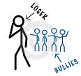

* **Verbal:** making threats, name-calling
* **Psychological:** excluding children, spreading rumors
* **Physical:** hitting, pushing, taking a child's possessions

**Gender makes a difference:** Bullying can be very different with girls and boys. With girls, bullying is often subtle. Girls can be mean without saying a word: by telling other girls not to be friends with a particular girl, giving her the silent treatment, rolling their eyes in class, or making rude noises. Sometimes, girls make a hurtful remark and then pretend they didn't mean it by saying "just kidding."  
   
Boys, on the other hand, tend to be more physical, boys push each other or take someone's sneaker and put it in the garbage, but they don't hold grudges. One boy can do something really mean to another boy and then later the same day they will be pals again.

**Working Together:** Everyone in a school, as well as parents and other students, must work together to make sure no kids are treated cruelly. It's not easy when you are the victim of a bully. If you see someone being bullied stand up for them.

Unfortunately, children are very rarely taught how to deal with bullies. This is such a tragedy because dealing with bullies is easy if you know some simple strategies. Children need a tool box of ways to handle bullies. Here are a few suggestions:

**Get Help:** Sometimes it is best for a victim to ask other people to help him or her to handle the bully. Victims may go to friends, teachers, parents, or other adults for help.

**Use Humor:** Remember that the bully wants to make you upset. So, instead of getting mad, try using a sense of humor. Be ready with a joke or you could also say something silly or ridiculous to the bully. You could also change the subject. Talk about a recent movie or popular television show.

**Avoid the Bully:** Try to stay away from the bully as best as possible. One example is that if a bully is over playing in the grass at recess, you could play on the playground equipment instead.

**Self- Talk:** "Self-Talk" means thinking in your head. If you are being bullied, think of good things about yourself. You can still feel good about yourself even if a bully is picking on you. It's kind of like playing a recording in your head that tells you that you are a great person despite what the bully thinks.

**Own It:** Sometimes what the bully says to you might be true, so you can "own" the comment. An example would be that if you are being made fun of for wearing glasses, you could respond by saying, "All the better to see you with." You can't deny you are wearing glasses if you are wearing them, but you don't have to be ashamed of it, either.

**C:\Documents and Settings\Mary\Local Settings\Temporary Internet Files\Content.IE5\QGM5WBGE\MCj04420300000[1].wmfNonfiction Text Response Sheet C:\Documents and Settings\Mary\Local Settings\Temporary Internet Files\Content.IE5\KOLH3Q6G\MCj04404240000[1].wmf**

**Title**

|  |
| --- |
| **Main Idea** |
|  |

|  |  |
| --- | --- |
| **Author’s Point of View** | **Evidence** |
|  |  |

|  |  |
| --- | --- |
| **Text Structures** | **Evidence** |
|  |  |

|  |  |
| --- | --- |
| **Opinion** | **Fact** |
|  |  |

**A Nation of Couch Potatoes**

The United States has a big problem. People are gaining weight. According to a report by the Center for Disease Control, one-third of American adults were obese, or extremely overweight, in 2007.

It’s not just adults who are getting bigger. A 2008 study published in the January 2010 issue of the Journal of the American Medical Association showed that 31.7% of American children are overweight compared to 29% in 1999. A study done in 2010 by the Kaiser Foundation found that 45,000 children between the ages of 2 to 19 are extremely obese across the U.S.

So why are so many people packing on the pounds? People gain weight when they take in more calories than they use up through activity. A calorie is a measure of the amount of energy that comes from food.

Exercise burns calories, but kids today aren’t moving as much as kids did in the past. Studies show that kids spend more time than ever before watching television, playing video games, sitting at computers or texting their friends. Some schools have also dropped recess in favor of more classroom time. Other schools have cut back on their PE programs. When kids do not exercise they gain weight.

Many families are busier than ever before. No one has time to prepare a home cooked meal. On average, it is estimated that an American kid eats a fast-food meal once every three days. At the same time, portions at many fast-food restaurants have become bigger. In 1957, the average hamburger weighed 1 ounce and had 210 calories. Today, it has grown to 6 ounces and contains 618 calories.

Some schools are beginning to help kids battle the bulge. Many have banned sodas and junk food from school. Vending machines are also banned in some schools. Other schools have started walking programs in the mornings before school starts.

Fast-food restaurants are also offering fruits, vegetables and juice as part of their kids’ meals. Even soda companies have started making a smaller size can for children.

Michelle Obama has made helping families eat better one of her top priorities during her husband’s presidency. She has spoken at many events about eating healthy. She also started a fruit and vegetable garden in the White House. This has prompted many families to start their own gardens as well.

**C:\Documents and Settings\Mary\Local Settings\Temporary Internet Files\Content.IE5\QGM5WBGE\MCj04420300000[1].wmfNonfiction Text Response Sheet C:\Documents and Settings\Mary\Local Settings\Temporary Internet Files\Content.IE5\KOLH3Q6G\MCj04404240000[1].wmf**

**Title**

|  |
| --- |
| **Main Idea** |
|  |

|  |  |
| --- | --- |
| **Author’s Point of View** | **Evidence** |
|  |  |

|  |  |
| --- | --- |
| **Text Structures** | **Evidence** |
|  |  |

|  |  |
| --- | --- |
| **Opinion** | **Fact** |
|  |  |

**The History of Skateboarding**

Skateboarding is a great sport and has an interesting history. Skateboarding was first started in the 1950s, when all across California surfers got the idea of trying to surf the streets. These creative first skateboarders made their own skateboards with wooden boxes or boards with roller skate wheels slapped on the bottom. Like you might imagine, a lot of people got hurt in the early years skateboarding! During this time, skateboarding was seen as something to do for fun after surfing.

By the 1960’s skateboarding was at its peak of popularity. Everyone was enjoying this fun past time so companies started to make skateboards. They were made of wood and had clay wheels. Unfortunately, it was hard to do tricks so people lost interest in the sport. Companies closed down so hardcore skateboarders were back to making their own boards again.

In 1973, a new wheel was invented in California. It was made of a plastic called urethane. It was similar to what is used today. The wheels now moved very quickly. Over the next few years the shape of the board was also improved. Riders could do many more tricks. Skateboarding once again became popular. Children all over California were realizing what an amazing sport it was.

However, streets were not safe for skateboarding. Good riders found that it was too easy to ride on streets. As a result, skateboard parks sprang up. The first parks were in California and Florida.

In 1976,the California drought forced homeowners to drain the water out of their pools. Skaters started using the pools to skate in. Amazing new tricks like aerials and the invert were invented.

In 1978, a skater named Alan Gelfand (nicknamed "Ollie") invented a new trick. He would slam his back foot down on the end of his board and jump, popping himself and the board into the air. This trick, named the ollie, helped to create many more tricks.

Unfortunately, near the end of the 1970's skateboarding once again began losing popularity. With less and less people skating, skate parks were forced to close. But hard core skaters kept skating anyway. Skateboarders started to build their own ramps at home, and to skate in any place they could find. They used handrails and walls to skate on. They started making the whole world into their own free skate park. This made people angry because they did not like their personal property being used as a skate park. Skateboarders were seen as bothersome and even as criminals.

However in 1984, Stacey Peralta and George Powell shot the first skateboarding videos. The team of skateboarders in the video included [Steve Caballero](http://skateboard.about.com/od/proskaterbios/p/Steve_Caballero.htm), [Tony Hawk](http://skateboard.about.com/od/proskaterbios/p/ProTonyHawk.htm), Mike McGill, Lance Mountain, [Rodney Mullen](http://skateboard.about.com/od/proskaterbios/p/ProRodneyMullen.htm), Stacy Peralta, and Kevin Staab. They eventually made lots of videos and kids all over the United States began watching them. They became interested in this fabulous hobby and so skateboarding once again became popular. This time it also began influencing clothing styles and music.

Since 2000, skateboarding video games, children's skateboards and skate parks have been popping up all over. Since a lot more money has been spent on skateboarding, there are better skateboards, and more skateboarding companies to keep inventing new things.

This is great news. Skateboarding is a fun sport for kids. It gives them exercise and keeps them outdoor away from the television and computer. Hopefully skateboarding will continue to be popular for years to come.

**C:\Documents and Settings\Mary\Local Settings\Temporary Internet Files\Content.IE5\QGM5WBGE\MCj04420300000[1].wmfNonfiction Text Response Sheet C:\Documents and Settings\Mary\Local Settings\Temporary Internet Files\Content.IE5\KOLH3Q6G\MCj04404240000[1].wmf**

**Title**

|  |
| --- |
| **Main Idea** |
|  |

|  |  |
| --- | --- |
| **Author’s Point of View** | **Evidence** |
|  |  |

|  |  |
| --- | --- |
| **Text Structures** | **Evidence** |
|  |  |

|  |  |
| --- | --- |
| **Opinion** | **Fact** |
|  |  |

**Education Around the World**

Today, all fifty states in America have many laws about education. One of these laws says all children must go to school. Each state collects tax money from people who own houses and other types of property. Taxes are used to build schools, buy books, and pay teachers. In that way, everyone can go to school.

However, depending on what time period or what country you live in, that is not always the case. For example, in ancient Greece, only boys were allowed to go to school. And their school was very different to the one that children of today attend. It was outside and the boys sat on dirt floors! They listened to their teacher whom they called wisdom seller. Also, it cost money so only boys from wealthy families were able to attend school. If you were not able to go to school, you stayed home with your father and learned his trade (job). Girls stayed home with their mothers and learned how to cook and clean. Girls from rich families had private tutors come to their home and teach them other skills.

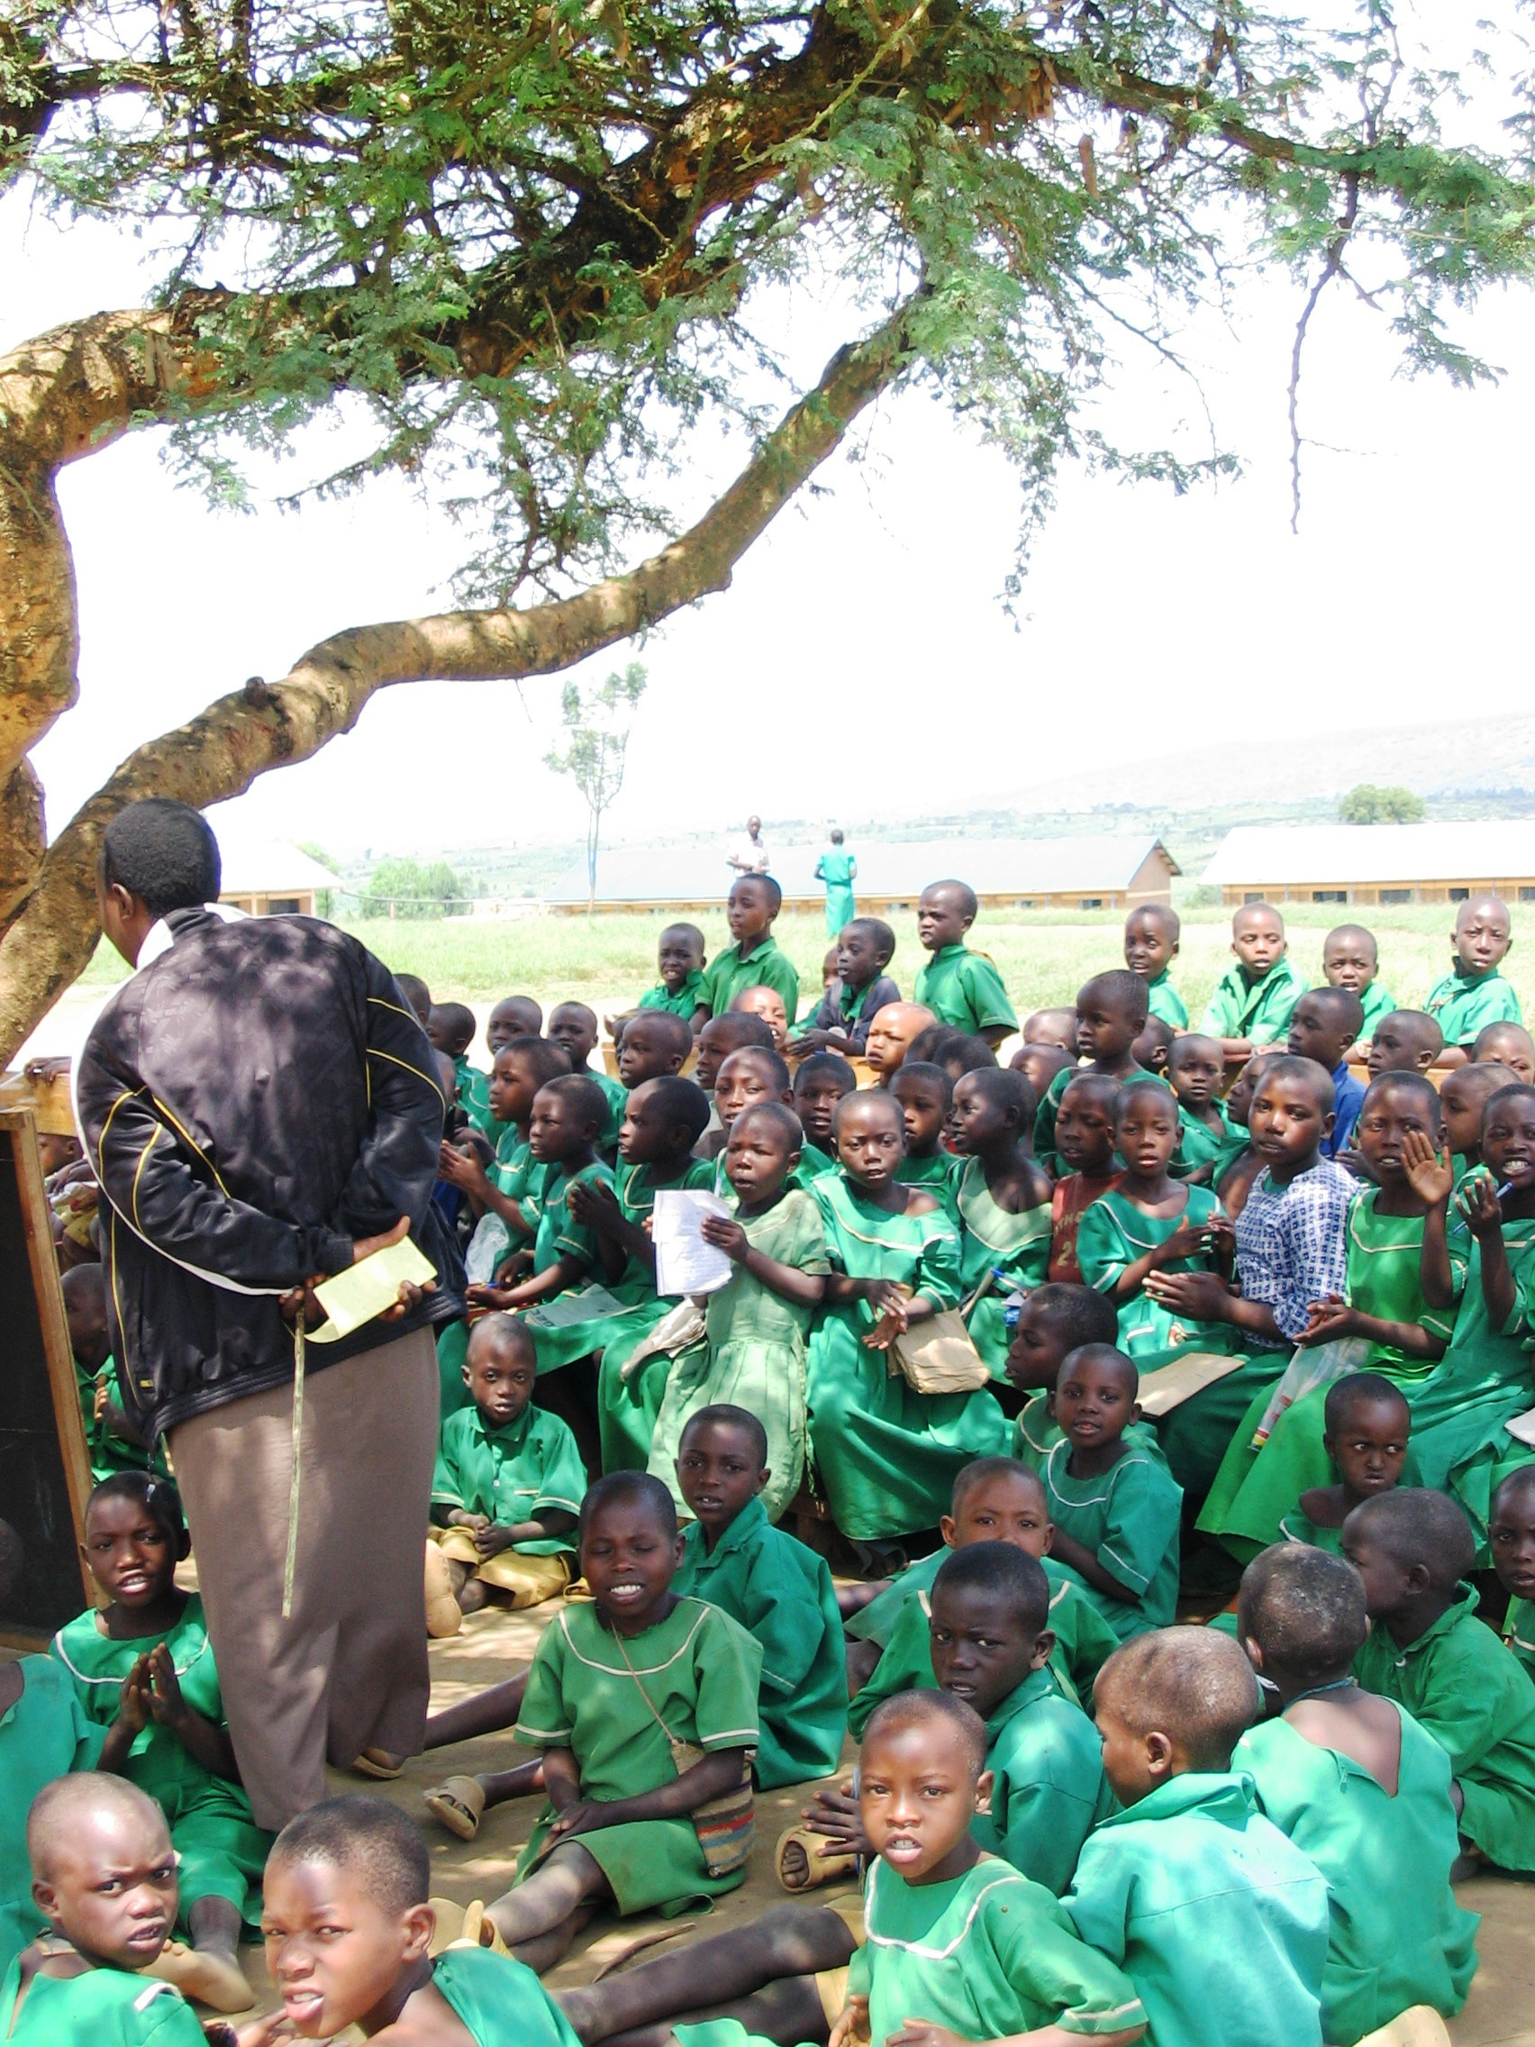

Unfortunately, education has not changed much in many countries around the world. Today, there are 100 million children worldwide who still do not attend school. In parts of Afghanistan, Pakistan, Africa and Indonesia, the few children that are lucky enough to get an education, still attend outdoor schools and sit on dirt floors. They do not have pencils or paper, so they write on the ground using sticks. They also have to share teachers with other villages. They might only have a teacher two or three days a week. The other days they practice their lessons on their own.

In many places it is actually illegal for girls to go to school. And in some places where it is legal, people still oppose it so girls are harassed and sometimes harmed if they attempt to go to school. Of the 100 million children who do not attend school, 73 million are girls! In parts of Kenya, Afghanistan, Pakistan and India, many young girls drop out of school to get married. Some are as young as 10 when their parents force them to marry! Others have to go to work to help support their families. Still others have families that simply do not have enough money to send their daughters to school. Many families can only afford to send some of their children to school, so they choose to send the boys. They unfairly believe that it not important for girls to go to school because they will just grow up and become mothers. The girls stay home and learn how to do housework and raise a family instead. However, it is just as important for girls to go to school as well as boys. Studies show that families, where both the mother and the father are educated, earn more money and are better able to take care of their children.

Girls should have the same opportunities to go to school as boys. Without an education, girls will need to work harder throughout their lives to keep up with boys. Also, when girls have an education they are able to earn more money so everyone in the family benefits. In China, Shi Caiyun, was not able to attend school because her family could not afford it. They only earned about 60 dollars a year! Through a program called Spring Bud she was eventually able to go to school. The program paid her tuition. She learned how to read and write. She also learned how to make money by growing kiwi fruit. Now Shi Caiyun’s family earns 180 a year! Her father finally agrees that schools are a good thing for girls too.

In America, during the Colonial days, education was also very different then it is today. Usually, people had to pay to send children to school as well. Not everyone could afford to send their children, and many young people, especially girls, never went to school. In school, most children were taught only to read and write. Children from rich families had a better education.

During the early 1800’s, people began to think it was important for all children to have an education. In 1852, Massachusetts passed a law which said that all children must go to school. Then other states passed education laws. At first, children only had to go to school four or five years. There were no high schools.

Now children must remain in school until they are sixteen. In some states, they must stay in school until they are eighteen. So in America, all children have a chance to learn.

Hopefully, one day, children all around the world will have the same opportunities that American children have. Thanks to hard working, caring people like, Greg Mortison, many more girls have the opportunity to become educated. He started a foundation that raises money to build schools for girls all over Pakistan. School children in the U.S. are helping out as well. They collect their pennies and send it to an organization called Pennies for Peace. The money is then used to build schools. Even the owner of a video store in San Diego, California is helping out children. He keeps a jar on his check out counter. When customers come to rent movies, they can deposit their change in the jar. He then uses the money to build schools, buy books and other school supplies for the children in his home country of Indonesia.

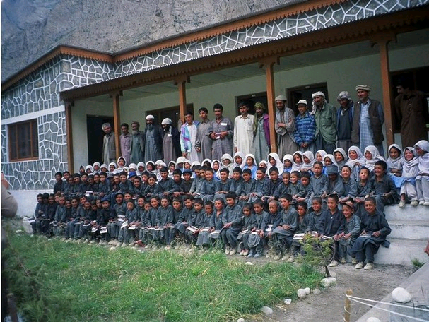

**C:\Documents and Settings\Mary\Local Settings\Temporary Internet Files\Content.IE5\QGM5WBGE\MCj04420300000[1].wmfNonfiction Text Response Sheet C:\Documents and Settings\Mary\Local Settings\Temporary Internet Files\Content.IE5\KOLH3Q6G\MCj04404240000[1].wmf**

**Title**

|  |
| --- |
| **Main Idea** |
|  |

|  |  |
| --- | --- |
| **Author’s Point of View** | **Evidence** |
|  |  |

|  |  |
| --- | --- |
| **Text Structures** | **Evidence** |
|  |  |

|  |  |
| --- | --- |
| **Opinion** | **Fact** |
|  |  |

**Ending Child Labor**

Child labor exists in two-thirds of the world’s countries. From Indonesia to Guatemala, poor children as young as 6 are sent off to work. In the country of Pakistan, there are 11 to 12 million children working! Many families earn very little money so they need their children to make money as well. However, the children are often mistreated and punished for not working hard enough. Sometimes they are sold as slaves.

In many parts of the world this horrible practice is in high demand because children are paid a lot less money than adults or sometimes not paid at all. In parts of India, children are sometimes kidnapped and sold to work in factories. Unfortunately, they are treated very cruelly. Many of them will die from malnutrition or disease.

However, child labor can and must be stopped. One solution to the child-labor problem in poor countries is education. Studies show that the more education you have the more money you earn. Parents with an education can afford to send their sons and daughters to school instead of work.

Another solution is awareness. When people find out which products are made by children, they will stop buying that product. In the 1990’s, it was discovered that many of the worlds’ soccer balls were made by children. 80% of soccer balls are made in Pakistan where the number of children working is extremely high. Fifa, the soccer worlds’ governing organization, responded by stopping to buy soccer balls made with child labor. Its seal of approval guarantees that soccer balls are made under proper working conditions.

**C:\Documents and Settings\Mary\Local Settings\Temporary Internet Files\Content.IE5\QGM5WBGE\MCj04420300000[1].wmfNonfiction Text Response Sheet C:\Documents and Settings\Mary\Local Settings\Temporary Internet Files\Content.IE5\KOLH3Q6G\MCj04404240000[1].wmf**

**Title**

|  |
| --- |
| **Main Idea** |
|  |

|  |  |
| --- | --- |
| **Author’s Point of View** | **Evidence** |
|  |  |

|  |  |
| --- | --- |
| **Text Structures** | **Evidence** |
|  |  |

|  |  |
| --- | --- |
| **Opinion** | **Fact** |
|  |  |