C:\Documents and Settings\Mary\Local Settings\Temporary Internet Files\Content.IE5\QGM5WBGE\MCj01049800000[1].wmf

C:\Documents and Settings\Mary\Local Settings\Temporary Internet Files\Content.IE5\5J8F9NN6\MCj01049780000[1].wmf C:\Documents and Settings\Mary\Local Settings\Temporary Internet Files\Content.IE5\X0AK08F7\MCj01049760000[1].wmf

C:\Documents and Settings\Mary\Local Settings\Temporary Internet Files\Content.IE5\QGM5WBGE\MCj01049840000[1].wmf

Natural Disasters

This packet belongs to:

**Can Animals Help us Detect Natural Disasters?**

**Wildlife Officials are Amazed that Few Animals Died in the Tsunami**

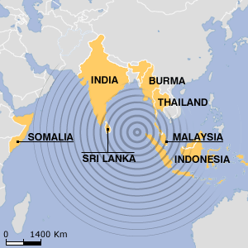

Map of area affected by the tsunami.

Hours before giant waves pounded coastlines in South Asia, many animals started behaving strangely. In Sri Lanka, elephants trumpeted frantically and fled to higher ground. Bats and flamingos deserted low-lying areas. Many other animals escaped unharmed.

Wildlife experts are amazed that many animals survived the tsunami. Experts say animals might have sensed the approaching waves and moved to higher ground.

The massive [tsunami](http://news.nationalgeographic.com/news/2004/12/1227_041226_tsunami.html) was triggered by a magnitude 9 earthquake off the coast of northern Sumatra island on December 26, 2004. The giant waves rolled through the Indian Ocean, killing more than 150,000 people in a dozen countries. However, relatively few animals have been reported dead. Along India's coast, where thousands of people died, the Indo-Asian News service reported that buffaloes, goats, and dogs were found unharmed.

Giant waves flooded low-lying parts of Yala National Park in Sri Lanka, home to a variety of animals, including elephants, leopards, monkeys, tigers, deer and 130 species of birds. The park employees reported only two water buffalos dead.

In Thailand, elephants carrying tourists bolted for the hills, and other elephants broke free of their chains. In one fishing village, nearly 1,000 locals escaped safely after birds squawked madly.

**More Wild Stories**

There have been many accounts of animals behaving strangely in other natural disasters as well. On February 28, 2001, a 6.8-magnitude quake struck the city of Seattle in the state of Washington. Animals behaved unusually beforehand. Some cats were said to be hiding for no apparent reason up to 12 hours before the earthquake; some dogs were barking frantically before the earthquake struck; and goats and other animals were showing obvious signs of fear.

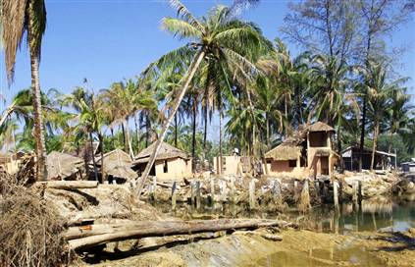

Resort in Thailand damaged by the tsunami.

Unusual animal behavior has also occured before avalanches. On February 23, 1999, an avalanche devastated a village in Austris killing dozens of people. The previous day, the chamois (small goat-like antelopes) came down from the mountains into the valleys, something they never usually do.

**Making Sense of It**

Why might animals have known trouble was on the way? Experts say that animals have better senses of hearing, smell, and sight than humans do. Those sharp senses help warn animals when natural disasters, such as volcano eruptions or earthquakes, are about to happen. At one time humans also had sharper senses, but lost the ability when it was no longer needed or used.

The senses of certain species are far stronger than what any human has. Dogs, for example, have a stronger sense of smell than humans and cats can see better in the dark than people.

Scientists say that animals might have felt the vibrations from the earthquake that set off the tsunami. In addition, many animals, including elephants, pigeons, and dogs, can also pick up infrasound. That is a sound that has too low of a pitch for humans to hear.

Elephants can hear or feel other elephants grumble up to 2 miles away, so they probably felt the earthquake. Their first instinct would be to move away from the direction of the sound.

Before the tsunami struck, animals may have started to flee because they saw other creatures running. Animals take their cues from other animals.

[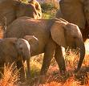](http://admin.satyacenter.com/item_files/article_347_0.jpg)

Elephants in Sri Lanka

**Hearing with Their Feet**

Scientists say that elephants can pick up vibration from earthquakes through their broad feet.

Elephants’ toenails are in the skin and not attached to the toes.

Elephants’ soles have sensitive foot pads that detect vibrations, such as those from an earthquake. This signals elephants to move to more stable ground.

**The Mystery Continues**

How animals sense danger has fascinated people for centuries. Most scientists, on the other hand, are skeptical.

"What we're faced with is a lot of anecdotes," said Andy Michael, a geophysicist. "Animals react to so many things—being hungry, defending their territories, mating, predators—so it's hard to have a controlled study to get that advanced warning signal."

In the 1970s a few studies on animal prediction were done, "but nothing concrete came out of it," Michael said. Since that time, there have been no further investigations into the theory of using animals to help us detect natural disasters.

#### However, in earthquake-prone areas of China, authorities have encouraged people to report unusual animal behavior, and Chinese scientists have an impressive track record in predicting earthquakes. In several cases they issued warnings that enabled cities to be evacuated hours before devastating earthquakes struck, saving tens of thousands of lives.

#### By paying attention to unusual animal behavior, as the Chinese do, earthquake warning systems might be possible in California, Greece, Turkey, Japan and elsewhere. Millions of pet owners and farmers in earthquake-prone areas could be asked to take part in this project through the media. They could be told what kinds of behavior their pets and other animals might show if an earthquake were about to happen. If people noticed these signs or any other unusual behavior, they could immediately call a telephone hotline with a memorable number - in California, say, 1-800-PET QUAKE. Or they could send a message on the Internet.

At present, many millions of dollars are being spent for setting up early warning systems to detect natural disasters. Using animals to help us detect natural disasters would only cost a fraction of what it costs to come up with high-tech machinery. I hope that those responsible for spending all this money will stop ignoring what animals can tell us.

**C:\Documents and Settings\Mary\Local Settings\Temporary Internet Files\Content.IE5\QGM5WBGE\MCj04420300000[1].wmfNonfiction Text Response Sheet C:\Documents and Settings\Mary\Local Settings\Temporary Internet Files\Content.IE5\KOLH3Q6G\MCj04404240000[1].wmf**

**Title**

|  |
| --- |
| **Main Idea** |
|  |

|  |  |
| --- | --- |
| **Author’s Point of View** | **Evidence** |
|  |  |

|  |  |
| --- | --- |
| **Text Structures** | **Evidence** |
|  |  |

|  |  |
| --- | --- |
| **Opinion** | **Fact** |
|  |  |

**Haiti and Chile: two earthquakes, two very different outcomes**

The 2010 earthquake in Chile was far stronger than the one that struck in Haiti – yet the death toll and destruction in Haiti was much higher. Haiti's earthquake killed some 220,000 people. Chile's death toll was only in the hundreds.

Not only was Chile a wealthier country but they were much better prepared for earthquakes as well. Their buildings were built much stronger, they had a robust emergency response system and a long history of handling earthquakes. No Haitian had ever experienced an earthquake at home when the Jan. 12, 2010 disaster destroyed their poorly constructed buildings leaving thousands of Haitians either dead or homeless. Earthquakes are quite common to Chile. However, the last one to hit Haiti was 250 years ago.

Chileans have homes and offices built to handle earthquakes. They have steel skeletons designed to sway with seismic waves rather than resist them. Some buildings in Chile were damaged from the earthquake, however none were completely destroyed like the ones in Haiti. In Haiti, by contrast, there were no building codes. Sadly, most of the buildings were not constructed to withstand earthquakes. Therefore, the city was completely leveled burying thousands of innocent citizens under the rubble.

And Chile was relatively lucky this time. Chile’s earthquake occurred in an area with a small population while Haiti’s earthquake struck right on the edge of the capital Port-au-Prince, a heavily populated city.

Unfortunately, Haitians were never taught how to react to an earthquake by sheltering under tables and door frames, and getting away from glass windows. On the other hand, Chile is a country where there are a lot of earthquakes so they were organized and prepared. Chile had many world-renowned seismologists and earthquake engineers working to not only make their buildings safe but to teach the public about earthquake safety as well.

Chile’s president was out giving minute-to-minute reports a few hours after the quake in the middle of the night. By contrast, most Haitians didn't know whether their president was alive or dead for at least a day after the quake. The National Palace and the president’s home had collapsed. Haiti's TV, cell phone networks and radio stations were knocked off the air by the earthquake as well.

Haiti, one of the poorest countries in the world, was hit hard by the earthquake. This is something that could have been completely prevented. It will take years to rebuild. Hopefully, Haiti will emerge a better and more prepared country so this does not happen again.

**C:\Documents and Settings\Mary\Local Settings\Temporary Internet Files\Content.IE5\QGM5WBGE\MCj04420300000[1].wmfNonfiction Text Response Sheet C:\Documents and Settings\Mary\Local Settings\Temporary Internet Files\Content.IE5\KOLH3Q6G\MCj04404240000[1].wmf**

**Title**

|  |
| --- |
| **Main Idea** |
|  |

|  |  |
| --- | --- |
| **Author’s Point of View** | **Evidence** |
|  |  |

|  |  |
| --- | --- |
| **Text Structures** | **Evidence** |
|  |  |

|  |  |
| --- | --- |
| **Opinion** | **Fact** |
|  |  |

**Vesuvius Erupts!**

It was a scorching-hot morning on August, 24 in the year 79 AD. The town of Pompeii baked in the sunshine. Pompeii was a city in Italy that sat at the foot of an active volcano named Mount Vesuvius.

Although it was very hot, the townspeople went about their daily chores. Some were at the public fountain collecting water for the day. Others went to the marketplace to buy bread and cheese for breakfast or olives and eggs for dinner. Farmers were out in their fields.

In the packed taverns, people spoke excitedly about the afternoon’s games in the amphitheater. This was a stadium where huge crowds gathered to watch trained warriors called gladiators fight each other. These were very violent and cruel fights.

Just then, the ground shook. The shoppers in the market place shrugged it off as just another earthquake. Earthquakes were common in this area and seen as just a fact of life. They seldom did much damage.

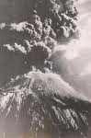

Suddenly there was a deafening boom – and the top of Mount Vesuvius, blew right off. A fountain of fire shot upward and huge black clouds rose into the sky. The ground shook with the force of the explosion.

Crowds ran screaming though the gloomy streets, upsetting market stalls and trampling fruit and vegetables underfoot. Even gladiators training in the amphitheater dropped their weapons and ran.

Some people rushed to save precious objects. Others tied cushions or towels to their heads for protection as they fled the streets of Pompeii. Men in charge of the areas warships turned their boats towards shore to help rescue the residents of Pompeii.

Ash spread by the winds rained down on the town for about 18 hours. Buildings started to collapse. Then high temperatures came, gases, dust, and more earthquakes came as well.

The Volcano’s eruption blanketed the town of Pompeii and the neighboring city of Herculaneum. Thousands of people died that day. Pompeii was buried under ten feet of ash while the town of Herculaneum was buried under 75 feet of ash.

Pompeii and Herculaneum were never rebuilt. The towns' locations were accidentally rediscovered in the 18th century. The ash preserved and protected a vibrant city against the elements until archaeologists unearthed this snapshot in time.

The area around Vesuvius is now open to visitors as a national park.

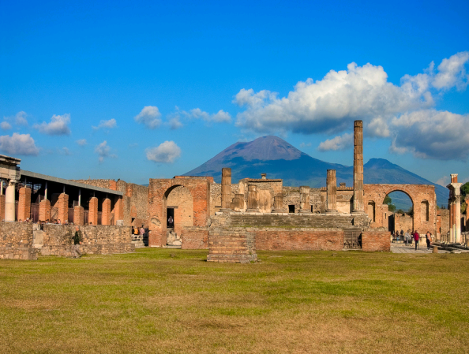

Mt. Vesuvius National Park

|  |
| --- |
|  |

**C:\Documents and Settings\Mary\Local Settings\Temporary Internet Files\Content.IE5\QGM5WBGE\MCj04420300000[1].wmfNonfiction Text Response Sheet C:\Documents and Settings\Mary\Local Settings\Temporary Internet Files\Content.IE5\KOLH3Q6G\MCj04404240000[1].wmf**

**Title**

|  |
| --- |
| **Main Idea** |
|  |

|  |  |
| --- | --- |
| **Author’s Point of View** | **Evidence** |
|  |  |

|  |  |
| --- | --- |
| **Text Structures** | **Evidence** |
|  |  |

|  |  |
| --- | --- |
| **Opinion** | **Fact** |
|  |  |